Batch: B1 Roll No.: 1711072

Experiment / assignment / tutorial No. 4

Grade: AA / AB / BB / BC / CC / CD /DD

Signature of the Staff In-charge with date

Title: Partitioning and formatting Hard Disk

AIM: To study about partitioning and Formatting Hard Disc.
______________________________________________________________________
Expected OUTCOME of Experiment:

CO 2: To assemble, administrate and upgrade the system.

_____________________________________________________________________
Books/ Journals/ Websites referred:
- IBM- PC BY Govindrajalu, THM
_____________________________________________________________________
Pre Lab/ Prior Concepts:
What is a hard disk partition?
When a hard drive is installed in a computer, it must be partitioned before you can format and use it. Partitioning a drive is when you divide the total storage of a drive into different pieces. These pieces are called partitions. Once a partition is created, it can then be formatted so that it can be used on a computer. When partitions are made, you specify the total amount of storage that you would like to allocate to that partition from the total size of the drive. For example, if you have an 80 GB drive, then it would be possible to make one partition consisting of the entire 80 GB of available storage. Alternatively, you could make two partitions consisting of a 20 GB partition that will be used for the operating system and programs and a 60 GB partition set aside for data, music, and images.

Why to make partitions?
Now that you know what a partition is, you may be wondering why you would even need to make multiple partitions instead of just making one. Though there are quite a few reasons, we will touch on some of the more important ones below:
- Organizing your data is easier: Partitioning a hard disk drive or solid state drive is a way to tell your computer to treat a single drive as logical disks. This allows you to precisely organize the data on these partitions, especially on large drives. For example, you can choose to have a partition for your documents, pictures, music or videos, another for your backup data, one for games and for whatever you need. Of course, you still need one partition dedicated to the operating system.
- In the case of OS failure, personal data is less likely to be affected: Nowadays, operating systems take backup and recovery seriously, so reaching a state where your system cannot be recovered is pretty hard. However, if the operating system fails, maybe because of a botched update or a malware infection, you may lose your personal data. Having at least two partitions - one for the operating system and one to keep your personal data - ensures that whenever you are forced to reinstall the operating system, your data remains untouched and you continue to have access to it. Also, it is much easier to back up a smaller partition that contains crucial files, and it is more convenient to store that data in a different place.
- Multi boot OS in your PC: Although there are not too many people who need or want to use multiple operating systems on their computers, there are some who do. Having two or more partitions on your computer is mandatory in this situation because each operating system needs a separate partition of its own. Also, you want to keep your files separated between operating systems, to be sure that while an operating system is running, it does not mess with the other's operating system files.

Creating and formatting a partition in Windows

Step 1: Access Disk Management
Disk Management is a handy utility built in Microsoft Windows that helps manage your hard drive disk. If you use keyboard and mouse, it’s the quickest way to open Disk Management in Windows 10 by pressing Win + X key to bring out Power User menu.

Step 2: Shrink volume
In Disk Management, it displays all drives connected to your Windows 10 PC. Now what you need to do is shrinking one disk partition.
1. Select one disk partition that has enough space, right click on it and select Shrink Volume.
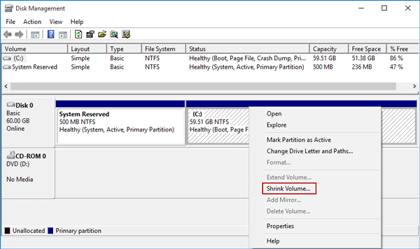
2. Just wait while querying shrink space. This will not take long.
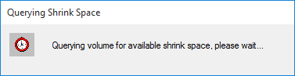
3. Now in the Shrink dialog, it displays four amounts. If you want to create a new 20 GB hard disk partition in your Windows 10, just enter 2048 (1GB=1024MB) in the field after Enter the amount of space to shrink in MB. Then click on Shrink.
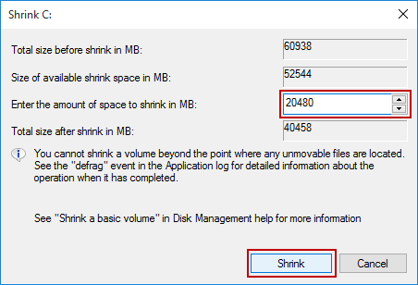

Step 3: Create new hard disk partition
Once you finish the step 2, you can see a new 20GB space that is unallocated.
1. Right click on the new space and select New Simple Volume.
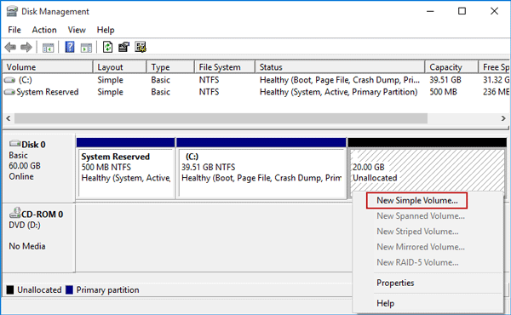

2. New Simple Volume Wizard opens. Click Next.
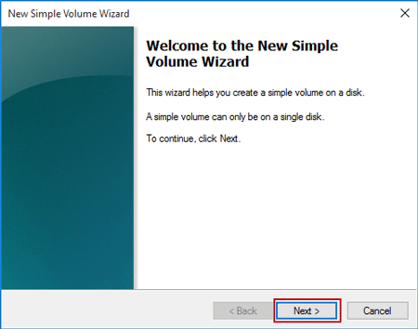
3. Specify size for the new volume and click Next. The volume size should be between the maximum and minimum sizes.
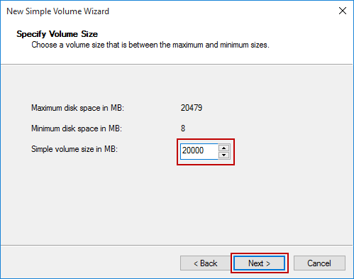
4. Assign a drive letter for the new created hard disk partition and then click Next.
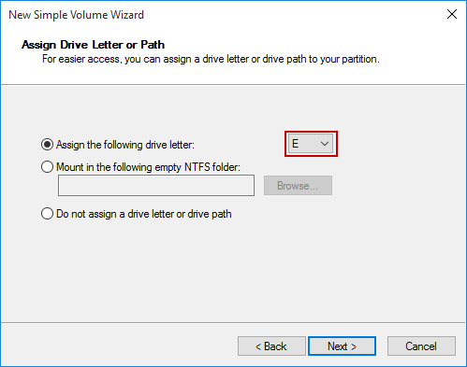
5. To store data on this partition, you must format it first. Just keep its default settings and enter the Volume label. Then click Next.
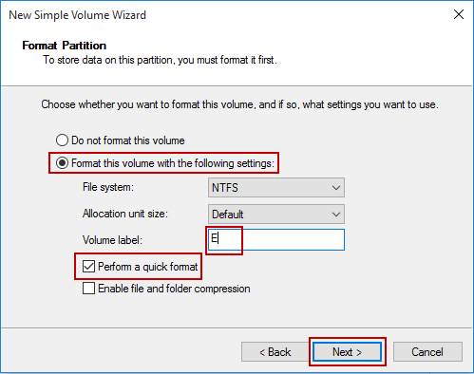
6. Click Finish to complete the New Simple Volume Wizard.
Then you’ve successfully created a new hard disk partition on your Windows 10 PC. If you specified the volume size less than the maximum disk space size, you can see an unallocated space on which you can create another disk partition.
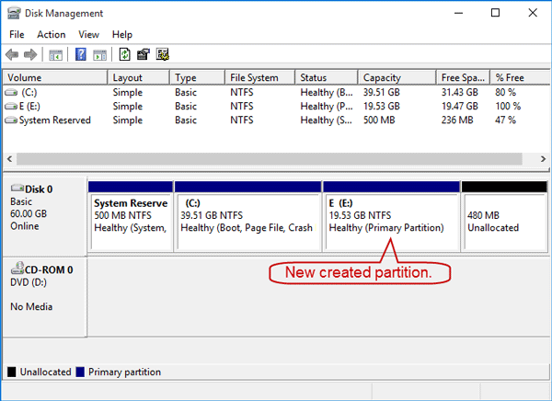

How to format a hard disk partition in Windows 10
Tips: Make sure you’ve backed up your personal data on another drive before you start a format on the disk partition.
Method 1: Still in Disk Management, right click on the partition and select Format.
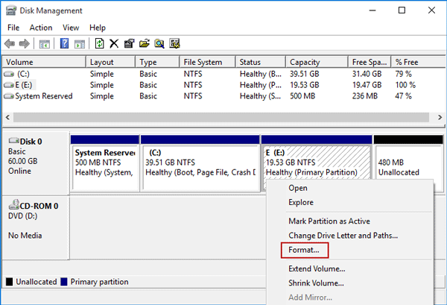
Tick Perform a quick format and click OK.
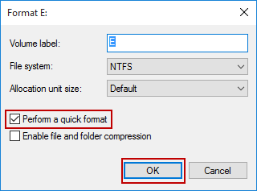
Method 2: Click File Explorer > This PC. Then right click on the drive partition and select Format.
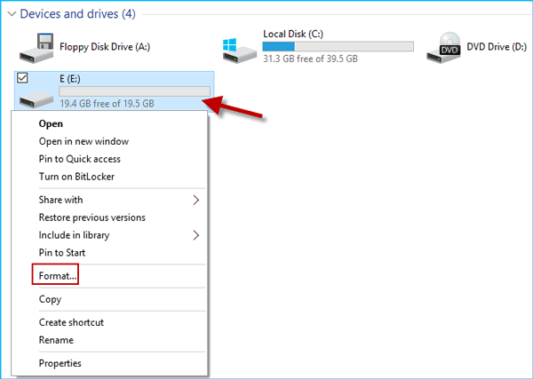
Just need to keep its default settings including tick the box next to Quick Format and click on Start.
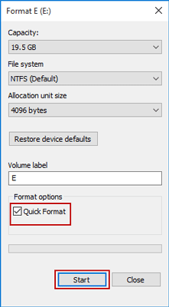
Deleting a partition in Windows
1] Using Disk Management
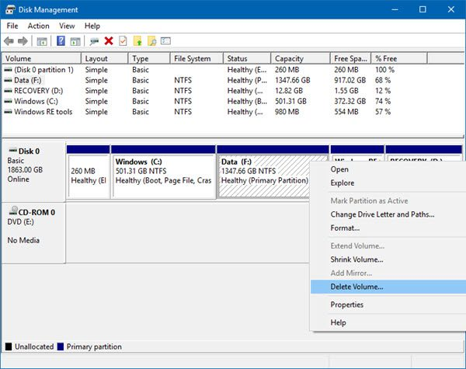
This one is simple. From the WinX Menu, open Disk Management, select the Drive you want to delete, right-click on it and then click on Delete Volume.

2] Using the Command Prompt
Start by pressing WINKEY + X button combo or right-click on the Start button and click on Command Prompt (Admin) or just search for cmd in the Cortana search box, right click on the Command Prompt icon and click on Run as Administrator.
Now, type in the following command,
diskpart
This will start the Diskpart Utility. It is a command line based utility just like the Command Prompt but will get a UAC Prompt once you invoke it. You have to click on Yes for the UAC Prompt.
Then, type in,
list volume
This will list all the partitions created on your computer. This will include both types of partitions that are visible to a normal user in the File Explorer and also the ones created by default by Windows 10 that help it to store the boot files and other important system files.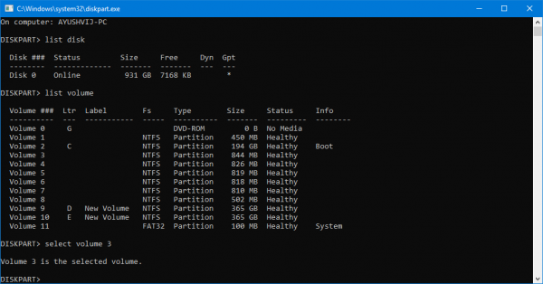
Now you will get a list of the partitions that are made on your computer.
Select the partition that you wish to delete by its Unique Identification number as Volume X where X denotes the Unique Identification Number.
Now, type in the following command to select the desired volume,
select volume number
Now, to delete the volume you just selected, type in the following command,
delete volume
Now, this will delete the volume you just selected and convert it into an unallocated space.

3] Using Windows PowerShell
First of all, start by pressing WINKEY + X button combo or right-click on the Start button and click on Windows PowerShell (Admin) or just search for Windows PowerShell in the Cortana search box, right click on the Command Prompt icon and click on Run as Administrator.
Now, type in the following command to get a list of all the partitions on your computer,
Get-Volume
Now, just select the drive letter that you wish to delete.
And then, enter the following command to delete that particular partition,
Remove-Partition -DriveLetter
Replace with the letter of the partition that you wish to delete.
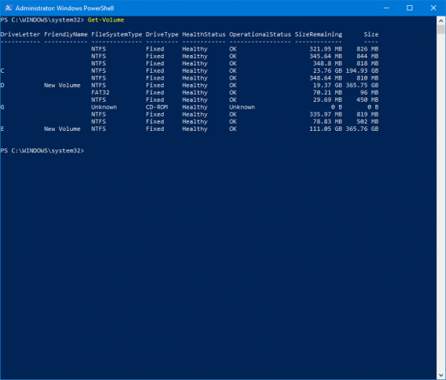
It will then ask you for a confirmation. Hit Y to say Yes or hit A to say Yes to All.
It will delete the partition you just selected and will move it in as an unallocated space.
This is how you delete a Volume or Drive Partition in Windows 10. We would only recommend the user to follow the last two methods in case the usual method with Disk Management is unable to fulfill the user’s requirements.

Conclusion: The partitioning was done successfully and formatting of hard disk and shrinking of volume was performed.
Post lab questions:
1) How to make active partitions?

Ans.
1. press WIN+R to open RUN box, type diskpart
2. in the opened window type list disk
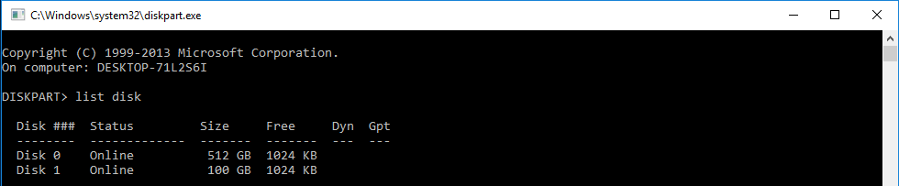
3. diskpart will list all the disks you have installed, type select disk ###
4. type list partition
5. type select partition ###
6. type active
Now you set this partition active, when you reboot, you can switch to another Windows system.
Set Active Partition in Disk Management
Set active partition in Disk management is another way to make partition bootable, Server 2008, Windows 10, and other Windows Systems can share steps as follow to set active partition:
1. Press shortcut key WIN+R to open RUN box, type diskmgmt.msc, or you can just right-click on Start bottom and select Disk Management in Windows 10 and Windows Server 2008
2. right-click on the partition you want to set active, choose Mark partition as active,
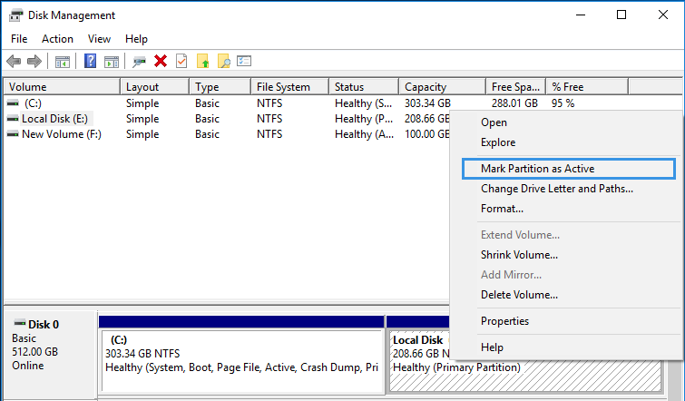
Set Active Partition in Partition Expert
1. Run Partition Expert, Right-click on one partition to Set Active
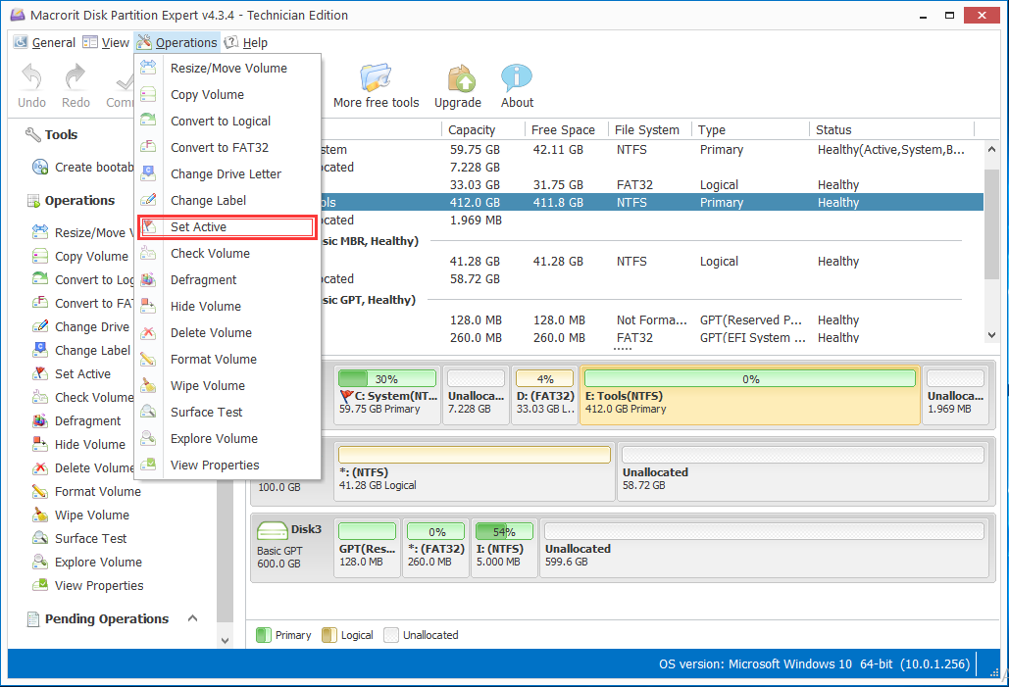
2. Then there is an alert: Setting this partition as active partition will set the other partition as inactive, Are you sure you want to set the partition as active?
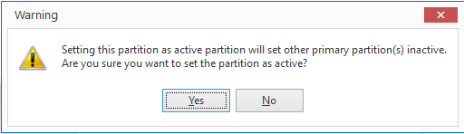
- Click YES to continue, > Commit.
Set Active Partition BIOS
1. Reboot your computer, when you say the message Press F# to enter setup, Press the bottom, and you will see BIOS interface.
2. Go into each menu and find terms with BOOT, may be BOOT ORDER, FIRST BOOT DEVICE, things like that, my pc shows Advance BIOS Features: First Boot Device, Second Boot Device, Third Boot Device. > Press Enter
3. Use up and down arrow key to choose between: HDD (hard drive), Floppy, CDROM, or Network; or between: CD-ROM Drive; Removable Devices; Hard Drive; Network boot. BIOS differs.
4. Exit and YES to Save changes

Date: 16/02/2019 Signature of faculty in-charge

